Deploying **M-Ticket** application in different accounts.

* Now i’m doing slave node only and its configuration.
* **Slave Configuration:**

Create User, ssh keys and copy it to authorized_keys.

* sudo apt install default-jre -y
* sudo adduser slave1
* sudo su slave1
* ssh-keygen -t rsa -N “ ” -f /home/slave1/.ssh/id_rsa
* cd .ssh/
* cat id_rsa.pub > authorized_keys
* chmod 700 authorized_keys

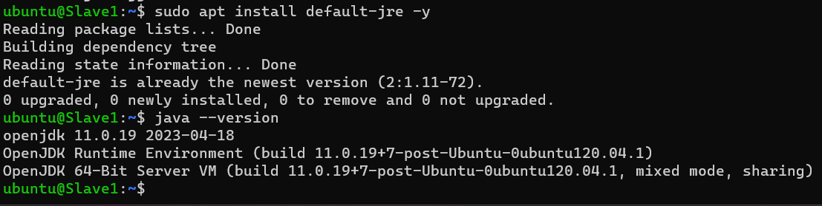

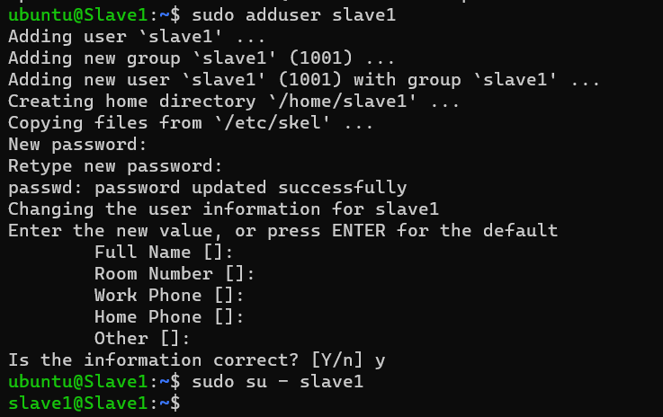

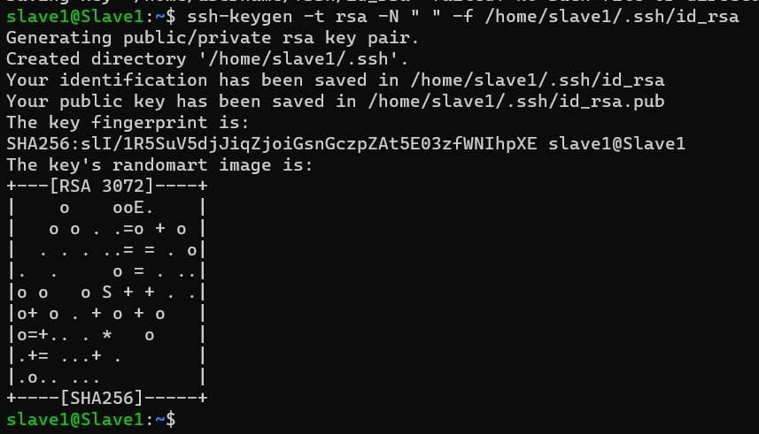

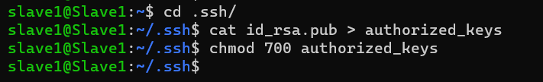

1. All configuration done by master he will do every step by step, what slave do is just browse the Ip address

